Aedificium Library System Requirements

Morgan Wood

September 19th, 2020

**Revision History**

|  |  |  |  |
| --- | --- | --- | --- |
| **Name** | **Date** | **Reason for Changes** | **Version** |
| Morgan Wood | 7/4/2020 | Initial Draft | 1.0 |
| Morgan Wood | 7/12/2020 | * Added Revision History * Changed Name of System * Added Domain Layer Class Diagram | 1.1 |
| Morgan Wood | 7/18/2020 | * Added Service Layer Class Diagram | 1.2 |
| Morgan Wood | 7/25/2020 | * Update the Service Layer Class Diagram | 1.3 |
| Morgan Wood | 8/1/2020 | * Added Use Cases * Changed the priority of Use Cases * Added Business Layer Class Diagram | 1.4 |
| Morgan Wood | 8/9/2020 | * Add JFrame Map * Add Main Layout * Add AddBook Layout * Add AddBorrower Layout * Add AddLibrarian Layout | 1.5 |
| Morgan Wood | 8/15/2020 | * Updated Domain Layer Class Diagram * Updated Services Layer Class Diagram * Updated Business Layer Class Diagram * Updated Window Layout | 1.6 |
| Morgan Wood | 8/29/2020 | * Rebuilt with Maven * Updated POM * Added Log4J * Added Log4j config file * Added logs to the code | 2.1 |
| Morgan Wood | 9/6/2020 | * Add SPC Class to domain * Added collections for Books, Borrowers, Librarians, and Checkouts * Updated Domain Layer class diagram | 2.2 |
| Morgan Wood | 9/19/2020 | * Updated Domain Layer Class Diagram * Updated Service Layer Class Diagram * Updated Business Layer Class Diagram | 2.3 |
| Morgan Wood | 9/27/2020 | Updated Services Layer Class Diagram | 2.4 |

**Project Description**

The document is meant to describe the purpose and usefulness of the Aedificium Library System (ALS), which is an application on the web with multiple functionalities.

The Aedificium Library is a proposed library at the Spring Creek (SPC) Google data center in Clarksville, TN. It will be open to all googlers that claim SPC as their home office. The contents of the library will initially be in book form only, but divided into three major sections: fiction, non-fiction, and self-help. There is a want to expand the library at a later date into other media, so this should be kept in mind.

Users are referred to as either “Borrowers”, for those who check out and return items, or “Librarians”, which is a borrower that can approve of item check outs and returns. Librarians will also add new items to the library as well as update data for books and borrowers if information is wrong. Borrowers can check out items for two weeks at a time. An email will remind them of the need to return the item 48 before it is late. There are no late fees, so a report can be generated which has information such as late items, the reading of this list at team meetings being the incentive to not be on the “bad list” and provide incentive to return items on time.

This application is to be developed in Java SE JDK 11, with Hibernate as a coordination tool to mySqL.

**Organization of System**

The layout of the system is simple. A server will run the application and hold the database of information. This server will be in the back of the library. A thin client will run an instance of the ALS on the librarian’s desk at the entrance to the library. Attached to the thin client will be a RFID reader which serves two purposes. The first is the scanning of borrowers id cards. The second is the scanning of RFID’s attached to items available for checkout. The GUI will be a simple layout of various choices for the librarian to select. All use cases will start at this screen with the exception of automatic emails.

**Organization of System**

* **Borrower -** Google employee who has SPC for a home office and is registered to check items out of the library.
* **Site Manager**  - Chooses head librarian, allocates resources and site space.
* **Librarian** - Same as a borrower, but with permissions to allow check out of items to other borrowers/themselves, keys to the library, ability to check items back into the system, and responsibility of reselving of all returned items. Answers to the Head Librarian.
* **Admin / Head Librarian (Grow Post 20% Project Holder)** - Holds and has all the responsibilities of librarian account, but also maintains the RSLMS. Answers to the Site Manager.

**Domain Layer Diagram**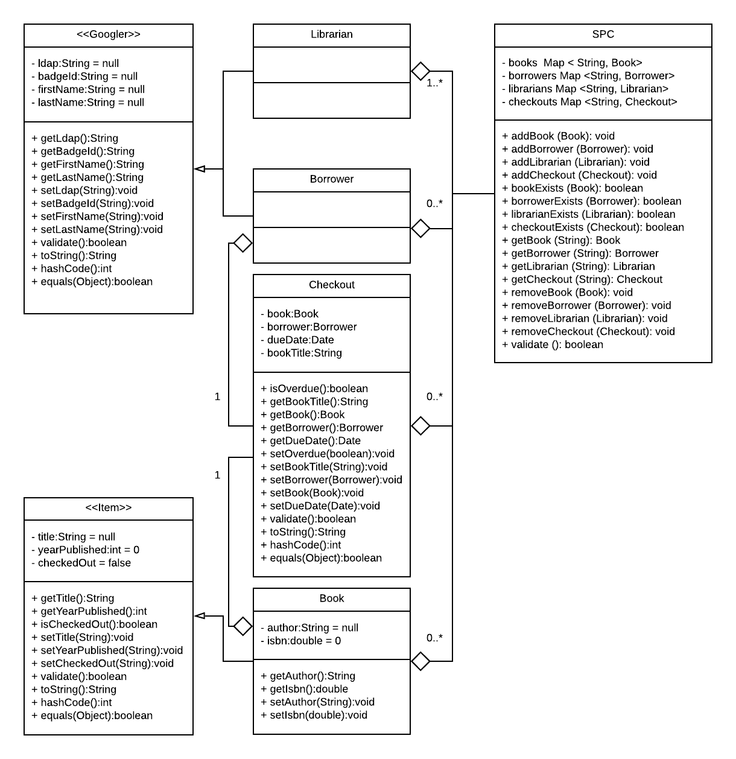

**Service Level Class Diagram**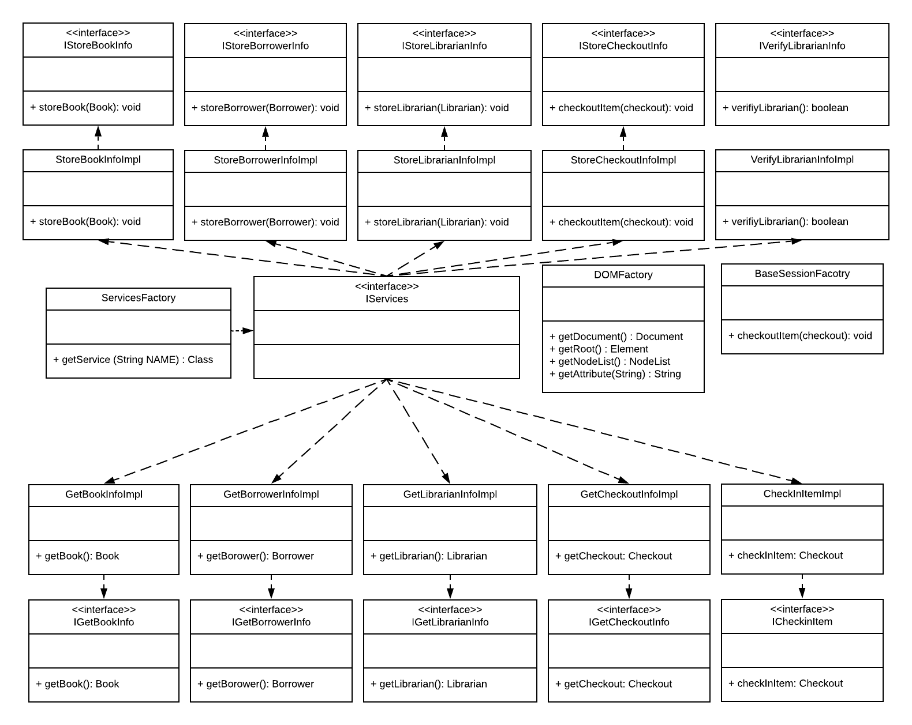

**Business Level Class Diagram**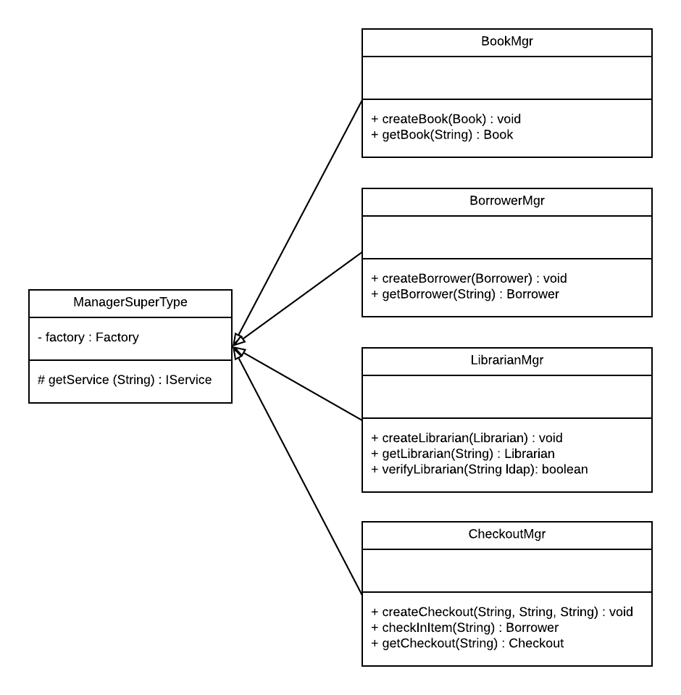

**List of Use Cases**

* **001 -** Registar New Borrower (Added)
* **002 -** Update Borrower Information
* **003 -** Add New Book to the Library (Added)
* **004 -** Change Item information in the system
* **005 -** Borrower Checks out Item(s) (Added)
* **006 -** Librarian Checks in Returned Item
* **007 -** Email Borrower about upcoming overdue item
* **008 -** Generate report
* **009 -** Register new Librarian (Added)
* **010 -** Update Librarian Information

**UML Use Case Diagrams**

|  |  |
| --- | --- |
| **Use case name:** | Registar New Borrower |
| **Use case ID:** | 001 |
| **Primary actors:** | Librarian |
| **Secondary actors:** | Borrower |
| **Brief description:** | New borrower account is created by the librarian. |
| **Preconditions:** | N/A |
| **Flow of events:** | 1. Librarian Selects “Create new borrower account”. 2. New borrower scans badge on RFID scanner. 3. Librarian scans their badgeID on RFID scanner. 4. Librarian inputs new borrowers information. 5. Librarian selects “Finish”. |
| **Post-conditions:** | New Borrower account is added to the system. |
| **Priority:** | 1 |
| **Alternative flows and exceptions:** | 2a. - ID for borrow already has an account.  2b. - Card Id is invalid.  3a. - Card scanned is not listed as a librarian in the system.  5a. -First Name contains numbers, symbols or spaces.  5b. -Last Name contains numbers, symbols or spaces.  5c. -ldap contains numbers, symbols or spaces or upper case letters. |
| **Non-behavioral requirements:** |  |
| **Assumptions:** | New borrower is a googler and has an LDAP and googler ID card. |
| **Issues:** |  |
| **Source:** | ALS |

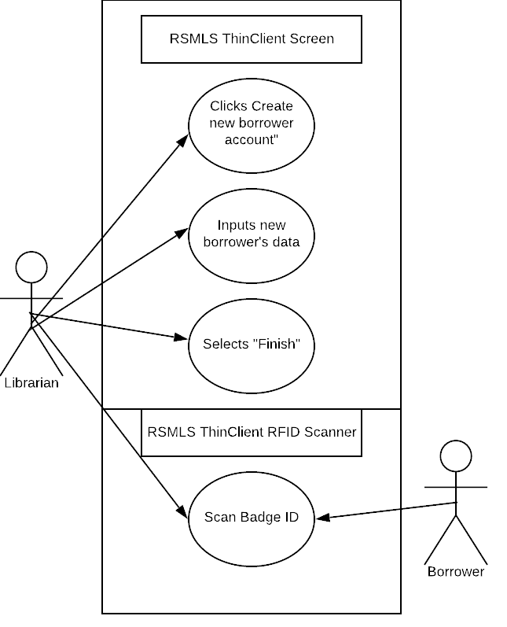

|  |  |
| --- | --- |
| **Use case name:** | Update Borrower Information |
| **Use case ID:** | 002 |
| **Primary actors:** | Librarian |
| **Secondary actors:** | Borrower |
| **Brief description:** | The information in the system for a borrower needs to be changed due to the change of LDAP, name, or status as a librarian. |
| **Preconditions:** | Borrower is already in the system per Use Case ID: 001. |
| **Flow of events:** | 1. Librarian Selects the “Update Borrower Information” on the main screen. 2. Borrower scans ID badge with RFID scanner. 3. Librarian scans their id badge with the RFID scanner. 4. Librarian updates the information that is desired. 5. Librarian Selects Update information. |
| **Post-conditions:** | Borrow information is updated in the system. |
| **Priority:** | 5 |
| **Alternative flows and exceptions:** | 2a. - ID for borrower does not have an account.  2b. - Card Id is invalid.  3a. - Card scanned is not listed as a librarian in the system.  5a. -First Name contains numbers, symbols or spaces.  5b. -Last Name contains numbers, symbols or spaces.  5c. -ldap contains numbers, symbols or spaces or upper case letters. |
| **Non-behavioral requirements:** |  |
| **Assumptions:** |  |
| **Issues:** |  |
| **Source:** | ALS |

|  |  |
| --- | --- |
| **Use case name:** | Add New Book to the Library |
| **Use case ID:** | 003 |
| **Primary actors:** | Librarian |
| **Secondary actors:** | N/A |
| **Brief description:** | A new book is added to the inventory of the library so that it can be checked out by borrowers. |
| **Preconditions:** |  |
| **Flow of events:** | 1. Librarian Selects the “Add new book to Library” on the main screen. 2. Librarian scans their id badge with the RFID scanner. 3. Librarian scans the new book’s RFID sticker with the RFID scanner. 4. Librarian inputs the book’s information. 5. Librarian selects “Finish”. |
| **Post-conditions:** | User has access to the system |
| **Priority:** | 2 |
| **Alternative flows and exceptions:** | 2a. - Card scanned is not listed as a librarian in the system.  3a. - Book is already in the system.  4a - Author's name contains numbers, symbols or spaces.  4b - ISBN contains letters or symbols.  4c - Copyright date year is not an integer. |
| **Non-behavioral requirements:** |  |
| **Assumptions:** | RFID Sticker is attached to the item.  Items is a book. New item types will be added in a later update. |
| **Issues:** |  |
| **Source:** | ALS |

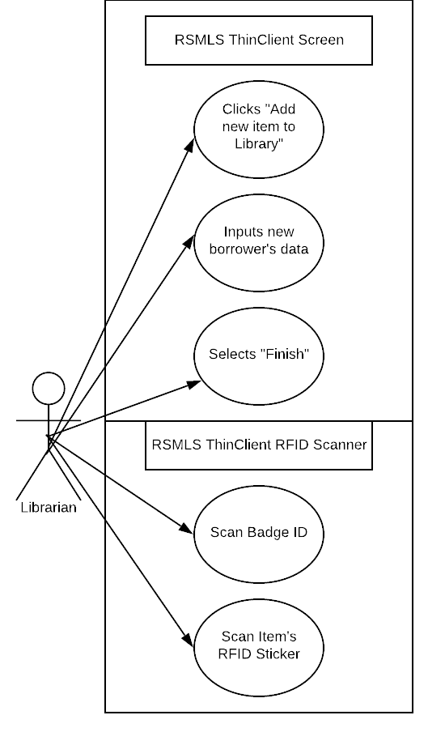

|  |  |
| --- | --- |
| **Use case name:** | Change Item information in the system |
| **Use case ID:** | 004 |
| **Primary actors:** | Librarian |
| **Secondary actors:** | N/A |
| **Brief description:** | Item information is updated in the system |
| **Preconditions:** | Item is already added to the system per the Use Case ID: 003. |
| **Flow of events:** | 1. Librarian Selects the “Update Item Information” on the main screen. 2. Librarian scans the item to be updated’s RFID sticker with the RFID scanner. 3. Librarian scans their id badge with the RFID scanner. 4. Librarian updates information within the system. 5. Librarian selects the “Update with current information” button. |
| **Post-conditions:** |  |
| **Priority:** | 6 |
| **Alternative flows and exceptions:** | 2a - Item ID is not already in the system.  3a. - Card scanned is not listed as a librarian in the system.  5a - Author's name contains numbers, symbols or spaces.  5b - ISBN contains letters or symbols.  5c - Copyright date year is not an integer. |
| **Non-behavioral requirements:** |  |
| **Assumptions:** | RFID Sticker is attached to the item.  Items is a book. New item types will be added in a later update. |
| **Issues:** |  |
| **Source:** | ALS |

|  |  |
| --- | --- |
| **Use case name:** | Borrow Checks out Item(s) |
| **Use case ID:** | 005 |
| **Primary actors:** | Librarian |
| **Secondary actors:** | Borrower |
| **Brief description:** | A librarian helps a borrower check out and item |
| **Preconditions:** |  |
| **Flow of events:** | 1. Librarian Selects the “Check out item” on the main screen. 2. Book’s RFID is scanned. 3. Borrower’s ID Badge is scanned. 4. Librarian's ID Badge is scanned. 5. “Finish Checkout” is selected. |
| **Post-conditions:** |  |
| **Priority:** | 9 |
| **Alternative flows and exceptions:** |  |
| **Non-behavioral requirements:** |  |
| **Assumptions:** | RFID Sticker is attached to the item. |
| **Issues:** |  |
| **Source:** | ALS |

|  |  |
| --- | --- |
| **Use case name:** | Librarian Checks in Returned Item |
| **Use case ID:** | 006 |
| **Primary actors:** | Librarian |
| **Secondary actors:** | N/A |
| **Brief description:** | Librarian scans items that are returned into the system so that they can be checked out again. |
| **Preconditions:** | Items that have been checked out in Use Case ID: 005 have been returned. |
| **Flow of events:** | 1. Librarian Selects the “Scan Returned Items” on the main screen. 2. Librarian scans their id badge with the RFID scanner. 3. Librarian scans the item to be returned’s RFID sticker with the RFID scanner. 4. If multiple items are to be returned, repeat step 3 until all returned items are scanned in. 5. Librarian selects the “Done Returning Items” button. |
| **Post-conditions:** |  |
| **Priority:** | 4 |
| **Alternative flows and exceptions:** | 3a - Item scanned is not “checked out”.  4a - If only one item is to be returned, step for is skipped. |
| **Non-behavioral requirements:** |  |
| **Assumptions:** | RFID Sticker is attached to the item. |
| **Issues:** |  |
| **Source:** | ALS |

|  |  |
| --- | --- |
| **Use case name:** | Email Borrower about upcoming overdue item |
| **Use case ID:** | 007 |
| **Primary actors:** | Borrower |
| **Secondary actors:** | N/A |
| **Brief description:** | An email is generated to a borrower to remind them of the due date 48hrs before the item is due. |
| **Preconditions:** |  |
| **Flow of events:** | 1. Timer activates the process.. 2. Email is generated. 3. Email is sent to the borrower. |
| **Post-conditions:** | Email notification is received by the borrower. |
| **Priority:** | 7 |
| **Alternative flows and exceptions:** | N/A |
| **Non-behavioral requirements:** |  |
| **Assumptions:** | Server is connected to the site internet. |
| **Issues:** |  |
| **Source:** | ALS |

|  |  |
| --- | --- |
| **Use case name:** | Generate report |
| **Use case ID:** | 008 |
| **Primary actors:** | Librarian |
| **Secondary actors:** | N/A |
| **Brief description:** | Generate a report of library data. |
| **Preconditions:** | N/A |
| **Flow of events:** | 1. Librarian Selects the “Generate Report” on the main screen. 2. System Generates report. 3. Report is emailed to all librarians. |
| **Post-conditions:** | Librarians have a new report in their email. |
| **Priority:** | 8 |
| **Alternative flows and exceptions:** | N/A |
| **Non-behavioral requirements:** |  |
| **Assumptions:** | Server is connected to the site internet. |
| **Issues:** |  |
| **Source:** | ALS |

|  |  |
| --- | --- |
| **Use case name:** | Register new Librarian |
| **Use case ID:** | 009 |
| **Primary actors:** | New Librarian |
| **Secondary actors:** | Old Librarian |
| **Brief description:** | New librarian account is created by the old librarian. |
| **Preconditions:** | N/A |
| **Flow of events:** | 1. Librarian Selects “Create new librarian account”. 2. New librarian scans badgeID on RFID scanner. 3. Old librarian scans their badgeID on an RFID scanner. 4. Old librarian inputs new librarian information. 5. Old librarian selects “Finish”. |
| **Post-conditions:** | New Librarian account is added to the system. |
| **Priority:** | 3 |
| **Alternative flows and exceptions:** | 2a. - ID for librarian already has an account.  2b. - Card Id is invalid.  3a. - Old librarian badgeID scanned is not listed as a Librarian in the system.  5a. -First Name contains numbers, symbols or spaces.  5b. -Last Name contains numbers, symbols or spaces.  5c. -ldap contains numbers, symbols or spaces or upper case letters. |
| **Non-behavioral requirements:** |  |
| **Assumptions:** | New librarian is a googler and has an LDAP and googler ID card. |
| **Issues:** |  |
| **Source:** | ALS |

|  |  |
| --- | --- |
| **Use case name:** | Update Librarian Information |
| **Use case ID:** | 010 |
| **Primary actors:** | Librarian w/ changes (Librarian) |
| **Secondary actors:** | Secondary Librarian |
| **Brief description:** | The information in the system for a librarian needs to be changed due to the change of LDAP, or name. |
| **Preconditions:** | Librarian is already in the system per Use Case ID: 009. |
| **Flow of events:** | 1. Secondary Librarian Selects the “Update Librarian Information” on the main screen. 2. Librarian scans ID badge with RFID scanner. 3. Secondary Librarian scans their id badge with the RFID scanner. 4. Librarian updates the information that is desired. 5. Librarian Selects Update information. |
| **Post-conditions:** | Borrow information is updated in the system. |
| **Priority:** | 10 |
| **Alternative flows and exceptions:** | 2a. - ID for librarian does not have an account.  2b. - Card Id is invalid.  3a. - Card scanned is not listed as a secondary librarian in the system.  5a. -First Name contains numbers, symbols or spaces.  5b. -Last Name contains numbers, symbols or spaces.  5c. -ldap contains numbers, symbols or spaces or upper case letters. |
| **Non-behavioral requirements:** |  |
| **Assumptions:** |  |
| **Issues:** |  |
| **Source:** | ALS |

**Windows Layout Diagram**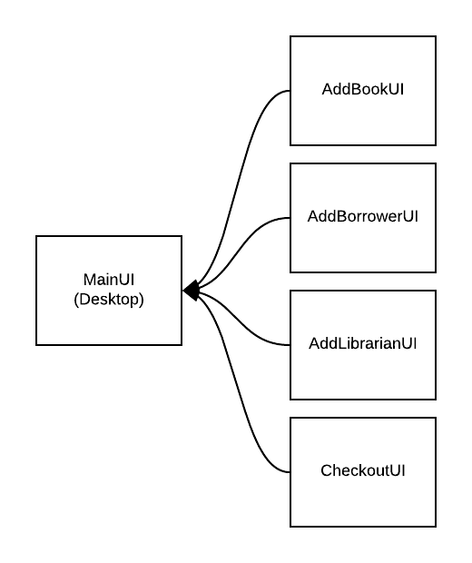

**Add Book JFrame Layout**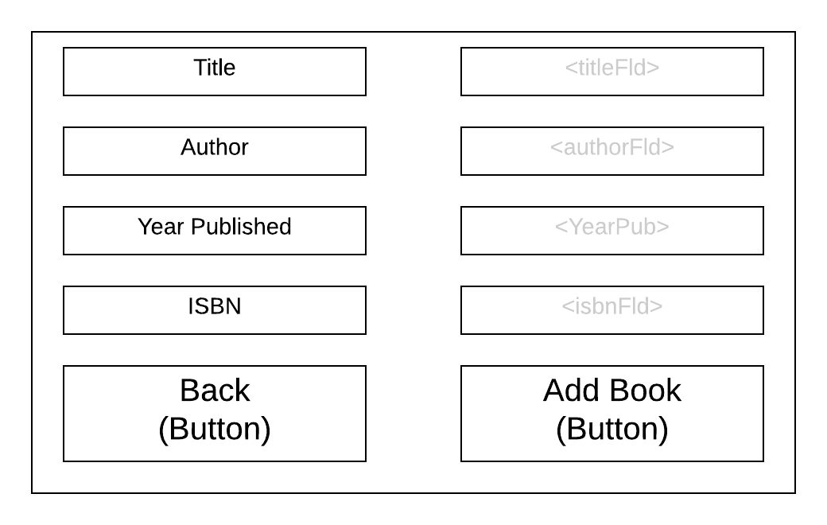

**Add Borrower JFrame**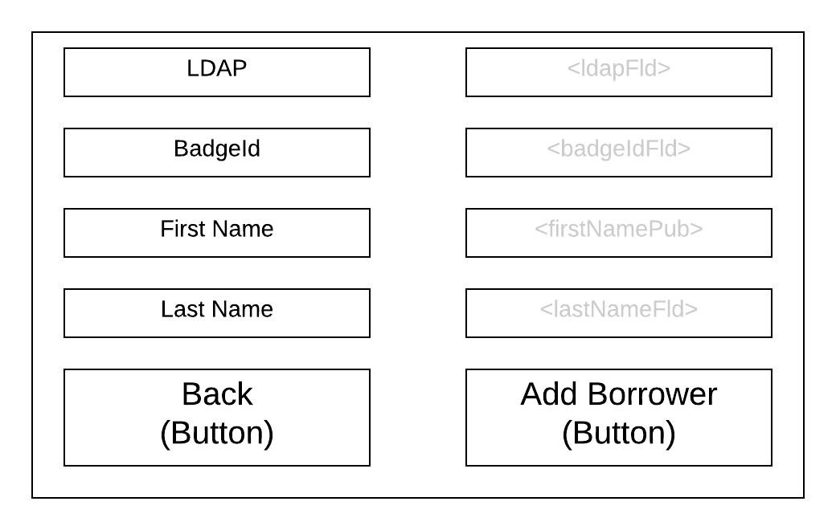

**Add Librarian JFrame**